Docker concepts

Docker is a platform for developers and sysadmins to **develop, deploy, and run** applications with containers. The use of Linux containers to deploy applications is called *containerization*. Containers are not new, but their use for easily deploying applications is.

Containerization is increasingly popular because containers are:

* Flexible: Even the most complex applications can be containerized.
* Lightweight: Containers leverage and share the host kernel.
* Interchangeable: You can deploy updates and upgrades on-the-fly.
* Portable: You can build locally, deploy to the cloud, and run anywhere.
* Scalable: You can increase and automatically distribute container replicas.
* Stackable: You can stack services vertically and on-the-fly.

## Docker Engine

It is a client server application that contains the following major components.

* A server which is a type of long-running program called a daemon process.
* **The REST API (web service)** is used to specify interfaces that programs can use to talk to the daemon and instruct it what to do.
* A command line interface client.

### Docker Introduction

# Docker Architecture

Docker follows client-server architecture. Its architecture consists mainly three parts.

1) **Client:** **Docker provides Command Line Interface (CLI) tools to client to interact with Docker daemon.** Client can build, run and stop application. Client can also interact to Docker_Host remotely.

2) **Docker_Host:** It contains Containers, Images, and **Docker daemon (services).** It provides complete environment to execute and run your application.

3) **Registry:** It is global repository of images **(db, application)**. You can access and use these images to run your application in Docker environment.

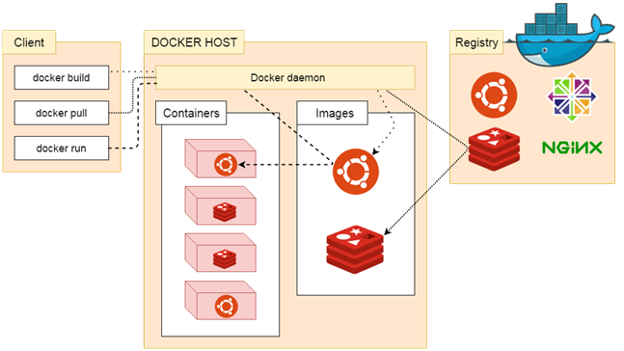

### The Docker daemon

It is a process which is used to listen for Docker API requests. It also manages Docker objects like: images, container, network etc. A daemon can also communicate with other daemons to manage Docker services.

### The Docker client

The Docker client is the primary way that many Docker users interact with Docker. When we use commands such as docker run, the client sends these commands to docker d, which carries them out. The docker command uses the Docker API.

### Docker Registries

Docker registry is used to store Docker images. Docker provides the Docker Hub and the Docker Cloud which are public registries that anyone can use. Docker is configured to look for images on Docker Hub by default.

When we use the docker pull or docker run commands, the required images are pulled from your configured registry. When you use the docker push command, your image is pushed to your configured registry.

### Images and containers

A container is launched by running an image. An **image** is an executable package that includes everything needed to run an application–the code, a runtime, libraries, environment variables, and configuration files.

A **container** is a runtime instance of an image–what the image becomes in memory when executed (that is, an image with state, or a user process). You can see a list of your running containers with the command, docker ps, just as you would in Linux.

# Docker Installation

We can install docker on any operating system whether it is Mac, Windows, Linux or any cloud. Docker Engine runs natively on Linux distributions. Here, we are providing step by step process to install docker engine for Linux **Ubuntu Xenial-16.04 [LTS].**

### Prerequisites:

Docker need two important installation requirements:

* It only works on a 64-bit Linux installation.
* It requires Linux kernel version 3.10 or higher.

To check your current kernel version, open a terminal and type **uname -r** command to display your kernel version:

**Command:**

1. $ uname -r

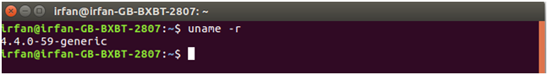

## Update apt sources

Follow following instructions to update apt sources.

1. Open a terminal window.
2. Login as a root user by using sudo command.
3. Update package information and install CA certificates.

**Command:**

* 1. $ apt-get update
  2. $ apt-get install apt-transport-https ca-certificates

See, the attached screen shot below.

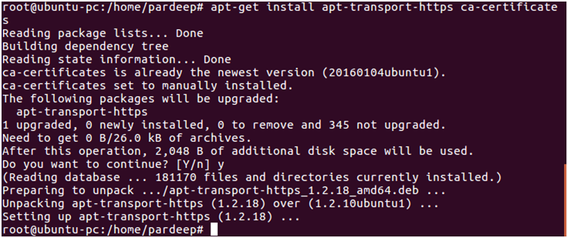

1. Add the new GPG key. Following command downloads the key.

**Command:**

* 1. $ sudo apt-key adv \
  2. --keyserver hkp://ha.pool.sks-keyservers.net:80 \
  3. --recv-keys 58118E89F3A912897C070ADBF76221572C52609D

Screen shot is given below.

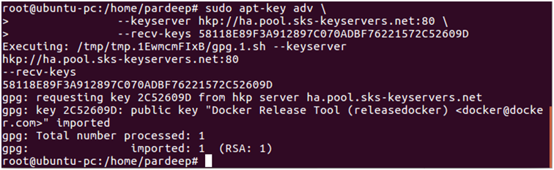

1. Run the following command, it will substitute the entry for your operating system for the file.
   1. $ echo "**<REPO>**" | sudo tee /etc/apt/sources.list.d/docker.list

See, the attached screen shot below.



1. Open the file /etc/apt/sources.list.d/docker.listand paste the following line into the file.
   1. deb https://apt.dockerproject.org/repo ubuntu-xenial main

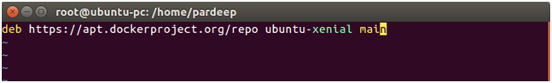

1. Now again update your apt packages index.
   1. $ sudo atp-get update

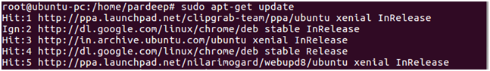

See, the attached screen shot below.

1. Verify that APT is pulling from the right repository.
   1. $ apt-cache policy docker-engine

See, the attached screen shot below.

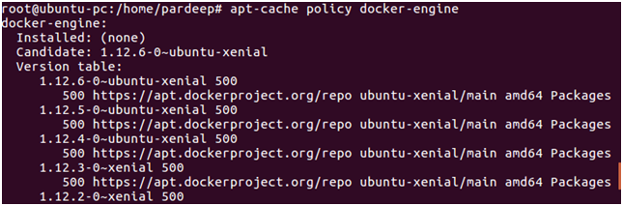

1. Install the recommended packages.
   1. $ sudo apt-get install linux-image-extra-$(uname -r) linux-image-extra-virtual

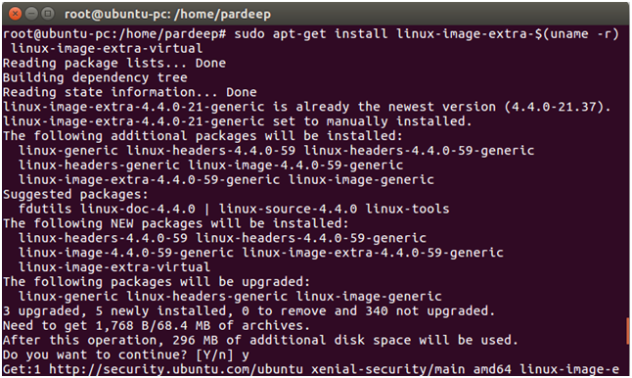

## Install the latest Docker version.

1. update your apt packages index.
   1. $ sudo apt-get update

See, the attached screen shot below.



1. Install docker-engine.
   1. $ sudo apt-get install docker-engine

See, the attached screen shot below.

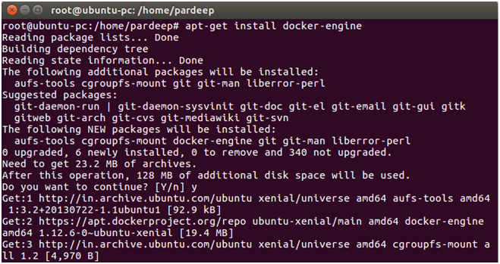

1. Start the docker daemon.
   1. $ sudo service docker start

See, the attached screen shot below.

Docker Installation 11

1. Verify that docker is installed correctly by running the hello-world image.
   1. $ sudo docker run hello-world

See, the attached screen shot below.

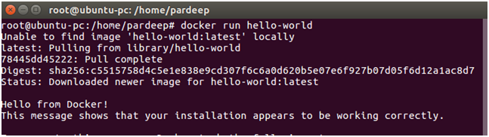

This above command downloads a test image and runs it in a container. When the container runs, it prints a message and exits.

# Docker Container and Image

Docker container is a running instance of an image. You can use Command Line Interface (CLI) commands to run, start, stop, move, or delete a container. You can also provide configuration for the network and environment variables. Docker container is an isolated and secure application platform, but it can share and access to resources running in a different host or container.

An image is a read-only template with instructions for creating a Docker container. A docker image is described in text file called a **Dockerfile**, which has a simple, well-defined syntax. An image does not have states and never changes. Docker Engine provides the core Docker technology that enables images and containers.

You can understand container and image with the help of the following command.

1. $ docker run hello-world

The above command **docker run hello-world** has three parts.

1) **docker:** It is docker engine and used to run docker program. It tells to the operating system that you are running docker program.

2) **run:** This subcommand is used to create and run a docker container.

3) **hello-world:** It is a name of an image. You need to specify the name of an image which is to load into the container.

### Docker Container

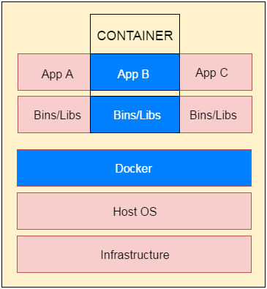

# Docker Dockerfile

A Dockerfile is a text document that contains commands that are used to assemble an image. We can use any command that call on the command line. Docker builds images automatically by reading the instructions from the Dockerfile.

The docker build command is used to build an image from the Dockerfile. You can use the -f flag with docker build to point to a Dockerfile anywhere in your file system.

1. $ docker build -f /path/to/a/Dockerfile .

## Dockerfile Instructions

The instructions are not case-sensitive but you must follow conventions which recommend to use uppercase.

Docker runs instructions of Dockerfile in top to bottom order. The first instruction must be **FROM** in order to specify the Base Image.

A statement begin with # treated as a comment. You can use RUN, CMD, FROM, EXPOSE, ENV etc instructions in your Dockerfile.

Here, we are listing some commonly used instructions.

### FROM

This instruction is used to set the Base Image for the subsequent instructions. A valid Dockerfile must have FROM as its first instruction.

Ex.

1. FROM ubuntu

### LABEL

We can add labels to an image to organize images of our project. We need to use LABEL instruction to set label for the image.

Ex.

1. LABEL vendorl = "JavaTpoint"

### RUN

This instruction is used to execute any command of the current image.

Ex.

1. RUN /bin/bash -c 'source $HOME/.bashrc; echo $HOME'

### CMD

This is used to execute application by the image. We should use CMD always in the following form

1. CMD ["executable", "param1", "param2"?]

This is preferred way to use CMD. There can be only one CMD in a Dockerfile. If we use more than one CMD, only last one will execute.

### COPY

This instruction is used to copy new files or directories from source to the filesystem of the container at the destination.

Ex.

1. COPY abc/ /xyz

**Rules**

* The source path must be inside the context of the build. We cannot COPY ../something /something because the first step of a docker build is to send the context directory (and subdirectories) to the docker daemon.
* If source is a directory, the entire contents of the directory are copied including filesystem metadata.

### WORKDIR

The WORKDIR is used to set the working directory for any RUN, CMD and COPY instruction that follows it in the Dockerfile. If work directory does not exist, it will be created by default.

We can use WORKDIR multiple times in a Dockerfile.

Ex.

1. WORKDIR /var/www/html

# Docker Java Application Example

As, we have mentioned earlier that docker can execute any application.

Here, we are creating a Java application and running by using the docker. This example includes the following steps.

1. **Create a directory**

Directory is required to organize files. Create a director by using the following command.

* 1. $ mkdir  java-docker-app

See, screen shot for the above command.

Docker Java application 1

1. **Create a Java File**

Now create a Java file. Save this file as **Hello.java** file.

**// Hello.java**

* 1. **class** Hello{
  2. **public** **static** **void** main(String[] args){
  3. System.out.println("This is java app \n by using Docker");
  4. }
  5. }

Save it inside the directory **java-docker-app** as Hello.java.

1. **Create a Dockerfile**

After creating a Java file, we need to create a Dockerfile which contains instructions for the Docker. Dockerfile does not contain any file extension. So, save it simple with **Dockerfile** name.

**// Dockerfile**

* 1. FROM java:8
  2. COPY . /var/www/java
  3. WORKDIR /var/www/java
  4. RUN javac Hello.java
  5. CMD ["java", "Hello"]

Write all instructions in uppercase because it is convention. Put this file inside **java-docker-app** directory. Now we have Dockerfile parallel to Hello.java inside the **java-docker-app** directory.

See, your folder inside must look like the below.

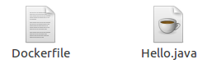

1. **Build Docker Image**

After creating Dockerfile, we are changing working directory.

* 1. $ cd   java-docker-app

See, the screen shot.

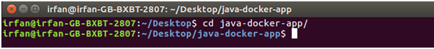

Now, create an image by following the below command. we must login as root in order to create an image. In this example, we have switched to as a root user. In the following command, **java-app**is name of the image. We can have any name for our docker image.

* 1. $ docker build -t java-app .

See, the screen shot of the above command.

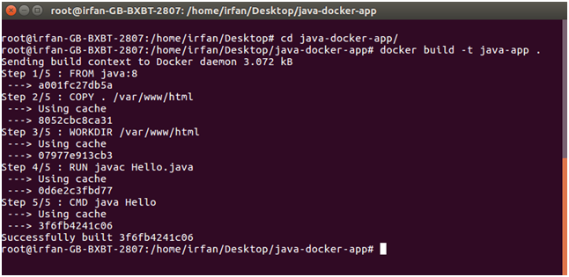

After successfully building the image. Now, we can run our docker image.

1. **Run Docker Image**

After creating image successfully. Now we can run docker by using run command. The following command is used to run java-app.

* 1. $ docker run java-app

See, the screen shot of the above command.

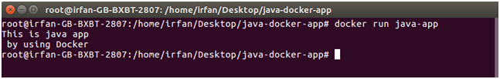

Here, we can see that after running the java-app it produced an output.

Now, we have run docker image successfully on your system. Apart from all these you can also use other commands as well.

### Containers and virtual machines

A **container** runs natively on Linux and shares the kernel of the host machine with other containers. It runs a discrete process, taking no more memory than any other executable, making it lightweight.

By contrast, a **virtual machine** (VM) runs a full-blown “guest” operating system with virtual access to host resources through a hypervisor. In general, VMs provide an environment with more resources than most applications need.

|  |  |
| --- | --- |
| Container stack example | Virtual machine stack example |

## Prepare your Docker environment

Install a [maintained version](https://docs.docker.com/engine/installation/#updates-and-patches) of Docker Community Edition (CE) or Enterprise Edition (EE) on a [supported platform](https://docs.docker.com/engine/installation/#supported-platforms).

**For full Kubernetes Integration**

* [Kubernetes on Docker for Mac](https://docs.docker.com/docker-for-mac/kubernetes/) is available in [17.12.0-ce Edge](https://docs.docker.com/docker-for-mac/release-notes/#docker-community-edition-17120-ce-mac45-2018-01-05-edge) or higher.
* [Kubernetes on Docker for Windows](https://docs.docker.com/docker-for-windows/kubernetes/) is available in [18.02.0-ce Edge](https://docs.docker.com/docker-for-windows/release-notes/#docker-community-edition-18020-ce-rc1-win50-2018-01-26-edge) or higher.

[Install Docker](https://docs.docker.com/engine/installation/)

### Test Docker version

Ensure that you have a supported version of Docker:

$ docker --version

Docker version 17.12.0-ce, build c97c6d6

Run docker version(without --) or docker info to view even more details about your docker installation:

$ docker info

Containers: 0

Running: 0

Paused: 0

Stopped: 0

Images: 0

Server Version: 17.12.0-ce

Storage Driver: overlay2

...

**Note**: To avoid permission errors (and the use of sudo), add your user to the docker group. Read more.

### Test Docker installation

Test that your installation works by running the simple Docker image, hello-world:

$ docker run hello-world

Unable to find image 'hello-world:latest' locally

latest: Pulling from library/hello-world

ca4f61b1923c: Pull complete

Digest: sha256:ca0eeb6fb05351dfc8759c20733c91def84cb8007aa89a5bf606bc8b315b9fc7

Status: Downloaded newer image for hello-world:latest

Hello from Docker!

This message shows that your installation appears to be working correctly.

...

List the hello-world image that was downloaded to your machine:

$ docker image ls

List the hello-world container (spawned by the image), which exits after displaying its message. If it were still running, you would not need the --all option:

$ docker container ls --all

CONTAINER ID IMAGE COMMAND CREATED STATUS

54f4984ed6a8 hello-world "/hello" 20 seconds ago Exited (0) 19 seconds ago

## Recap and cheat sheet

## List Docker CLI commands

docker

docker container --help

## Display Docker version and info

docker --version

docker version

docker info

## Excecute Docker image

docker run hello-world

## List Docker images

docker image ls

## List Docker containers (running, all, all in quiet mode)

docker container ls

docker container ls -all

docker container ls -a -q

# Containers

## Introduction

It’s time to begin building an app the Docker way. We start at the bottom of the hierarchy of such an app, which is a container, which we cover on this page. Above this level is a service, which defines how containers behave in production, covered in Part 3. Finally, at the top level is the stack, defining the interactions of all the services, covered in Part 5.

* Stack
* Services
* **Container** (you are here)

## Your new development environment

In the past, if you were to start writing a Python app, your first order of business was to install a Python runtime onto your machine. But, that creates a situation where the environment on your machine needs to be perfect for your app to run as expected, and also needs to match your production environment.

With Docker, you can just grab a portable Python runtime as an image, no installation necessary. Then, your build can include the base Python image right alongside your app code, ensuring that your app, its dependencies, and the runtime, all travel together.

These portable images are defined by something called a Dockerfile.

## Define a container with Dockerfile

Dockerfile defines what goes on in the environment inside your container. Access to resources like networking interfaces and disk drives is virtualized inside this environment, which is isolated from the rest of your system, so you need to map ports to the outside world, and be specific about what files you want to “copy in” to that environment. However, after doing that, you can expect that the build of your app defined in this Dockerfile behaves exactly the same wherever it runs.

### Dockerfile

Create an empty directory. Change directories (cd) into the new directory, create a file called Dockerfile, copy-and-paste the following content into that file, and save it. Take note of the comments that explain each statement in your new Dockerfile.

# Use an official Python runtime as a parent image

FROM python:2.7-slim

# Set the working directory to /app

WORKDIR /app

# Copy the current directory contents into the container at /app

ADD . /app

# Install any needed packages specified in requirements.txt

RUN pip install --trusted-host pypi.python.org -r requirements.txt

# Make port 80 available to the world outside this container

EXPOSE 80

# Define environment variable

ENV NAME World

# Run app.py when the container launches

CMD ["python", "app.py"]

**Are you behind a proxy server?**

Proxy servers can block connections to your web app once it’s up and running. If you are behind a proxy server, add the following lines to your Dockerfile, using the ENV command to specify the host and port for your proxy servers:

# Set proxy server, replace host:port with values for your servers

ENV http_proxy host:port

ENV https_proxy host:port

Add these lines before the call to pip so that the installation succeeds.

This Dockerfile refers to a couple of files we haven’t created yet, namely app.py and requirements.txt. Let’s create those next.

## The app itself

Create two more files, requirements.txt and app.py, and put them in the same folder with the Dockerfile. This completes our app, which as you can see is quite simple. When the above Dockerfile is built into an image, app.py andrequirements.txt is present because of that Dockerfile’s ADD command, and the output from app.py is accessible over HTTP thanks to the EXPOSE command.

### requirements.txt

Flask

Redis

### app.py

from flask import Flask

from redis import Redis, RedisError

import os

import socket

# Connect to Redis

redis = Redis(host="redis", db=0, socket_connect_timeout=2, socket_timeout=2)

app = Flask(__name__)

@app.route("/")

def hello():

try:

visits = redis.incr("counter")

except RedisError:

visits = "<i>cannot connect to Redis, counter disabled</i>"

html = "<h3>Hello {name}!</h3>" \

"<b>Hostname:</b> {hostname}<br/>" \

"<b>Visits:</b> {visits}"

return html.format(name=os.getenv("NAME", "world"), hostname=socket.gethostname(), visits=visits)

if __name__ == "__main__":

app.run(host='0.0.0.0', port=80)

Now we see that pip install -r requirements.txt installs the Flask and Redis libraries for Python, and the app prints the environment variable NAME, as well as the output of a call to socket.gethostname(). Finally, because Redis isn’t running (as we’ve only installed the Python library, and not Redis itself), we should expect that the attempt to use it here fails and produces the error message.

**Note**: Accessing the name of the host when inside a container retrieves the container ID, which is like the process ID for a running executable.

That’s it! You don’t need Python or anything in requirements.txt on your system, nor does building or running this image install them on your system. It doesn’t seem like you’ve really set up an environment with Python and Flask, but you have.

## Build the app

We are ready to build the app. Make sure you are still at the top level of your new directory. Here’s what ls should show:

$ ls

Dockerfile app.py requirements.txt

Now run the build command. This creates a Docker image, which we’re going to tag using -t so it has a friendly name.

docker build -t friendlyhello .

Where is your built image? It’s in your machine’s local Docker image registry:

$ docker image ls

REPOSITORY TAG IMAGE ID

friendlyhello latest 326387cea398

## Run the app

Run the app, mapping your machine’s port 4000 to the container’s published port 80 using -p:

docker run -p 4000:80 friendlyhello

You should see a message that Python is serving your app at http://0.0.0.0:80. But that message is coming from inside the container, which doesn’t know you mapped port 80 of that container to 4000, making the correct URL http://localhost:4000.

Go to that URL in a web browser to see the display content served up on a web page.

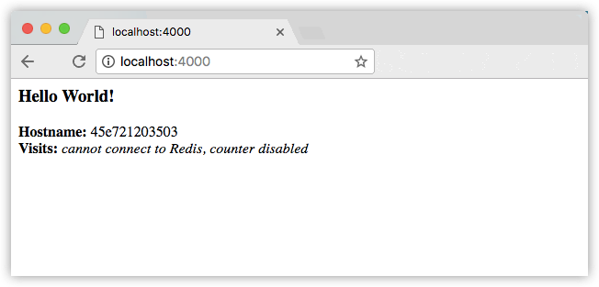

**Note**: If you are using Docker Toolbox on Windows 7, use the Docker Machine IP instead of localhost. For example, http://192.168.99.100:4000/. To find the IP address, use the command docker-machine ip.

You can also use the curl command in a shell to view the same content.

$ curl http://localhost:4000

<h3>Hello World!</h3><b>Hostname:</b> 8fc990912a14<br/><b>Visits:</b> <i>cannot connect to Redis, counter disabled</i>

This port remapping of 4000:80 is to demonstrate the difference between what you EXPOSE within the Dockerfile, and what you publish using docker run -p. In later steps, we just map port 80 on the host to port 80 in the container and use http://localhost.

Hit CTRL+C in your terminal to quit.

**On Windows, explicitly stop the container**

On Windows systems, CTRL+C does not stop the container. So, first type CTRL+C to get the prompt back (or open another shell), then type docker container ls to list the running containers, followed bydocker container stop <Container NAME or ID> to stop the container. Otherwise, you get an error response from the daemon when you try to re-run the container in the next step.

Now let’s run the app in the background, in detached mode:

docker run -d -p 4000:80 friendlyhello

You get the long container ID for your app and then are kicked back to your terminal. Your container is running in the background. You can also see the abbreviated container ID with docker container ls (and both work interchangeably when running commands):

$ docker container ls

CONTAINER ID IMAGE COMMAND CREATED

1fa4ab2cf395 friendlyhello "python app.py" 28 seconds ago

Notice that CONTAINER ID matches what’s on http://localhost:4000.

Now use docker container stop to end the process, using the CONTAINER ID, like so:

docker container stop 1fa4ab2cf395

## Share your image

To demonstrate the portability of what we just created, let’s upload our built image and run it somewhere else. After all, you need to know how to push to registries when you want to deploy containers to production.

A registry is a collection of repositories, and a repository is a collection of images—sort of like a GitHub repository, except the code is already built. An account on a registry can create many repositories. The docker CLI uses Docker’s public registry by default.

**Note**: We use Docker’s public registry here just because it’s free and pre-configured, but there are many public ones to choose from, and you can even set up your own private registry using Docker Trusted Registry.

### Log in with your Docker ID

If you don’t have a Docker account, sign up for one at cloud.docker.com. Make note of your username.

Log in to the Docker public registry on your local machine.

$ docker login

### Tag the image

The notation for associating a local image with a repository on a registry is username/repository:tag. The tag is optional, but recommended, since it is the mechanism that registries use to give Docker images a version. Give the repository and tag meaningful names for the context, such as get-started:part2. This puts the image in the get-started repository and tag it as part2.

Now, put it all together to tag the image. Run docker tag image with your username, repository, and tag names so that the image uploads to your desired destination. The syntax of the command is:

docker tag image username/repository:tag

For example:

docker tag friendlyhello john/get-started:part2

Run docker image ls to see your newly tagged image. (You can also use docker image ls.)

$ docker image ls

REPOSITORY TAG IMAGE ID CREATED SIZE

friendlyhello latest d9e555c53008 3 minutes ago 195MB

john/get-started part2 d9e555c53008 3 minutes ago 195MB

python 2.7-slim 1c7128a655f6 5 days ago 183MB

...

### Publish the image

Upload your tagged image to the repository:

docker push username/repository:tag

Once complete, the results of this upload are publicly available. If you log in to Docker Hub, you see the new image there, with its pull command.

### Pull and run the image from the remote repository

From now on, you can use docker run and run your app on any machine with this command:

docker run -p 4000:80 username/repository:tag

If the image isn’t available locally on the machine, Docker pulls it from the repository.

$ docker run -p 4000:80 john/get-started:part2

Unable to find image 'john/get-started:part2' locally

part2: Pulling from john/get-started

10a267c67f42: Already exists

f68a39a6a5e4: Already exists

9beaffc0cf19: Already exists

3c1fe835fb6b: Already exists

4c9f1fa8fcb8: Already exists

ee7d8f576a14: Already exists

fbccdcced46e: Already exists

Digest: sha256:0601c866aab2adcc6498200efd0f754037e909e5fd42069adeff72d1e2439068

Status: Downloaded newer image for john/get-started:part2

* Running on http://0.0.0.0:80/ (Press CTRL+C to quit)

No matter where docker run executes, it pulls your image, along with Python and all the dependencies from requirements.txt, and runs your code. It all travels together in a neat little package, and you don’t need to install anything on the host machine for Docker to run it.

## Conclusion of part two

That’s all for this page. In the next section, we learn how to scale our application by running this container in a **service**.

# Services

## Introduction

In part 3, we scale our application and enable load-balancing. To do this, we must go one level up in the hierarchy of a distributed application: the **service**.

* Stack
* **Services** (you are here)
* Container (covered in part 2)

## About services

In a distributed application, different pieces of the app are called “services.” For example, if you imagine a video sharing site, it probably includes a service for storing application data in a database, a service for video transcoding in the background after a user uploads something, a service for the front-end, and so on.

Services are really just “containers in production.” A service only runs one image, but it codifies the way that image runs—what ports it should use, how many replicas of the container should run so the service has the capacity it needs, and so on. Scaling a service changes the number of container instances running that piece of software, assigning more computing resources to the service in the process.

Luckily it’s very easy to define, run, and scale services with the Docker platform – just write a docker-compose.yml file.

## Your first docker-compose.yml file

A docker-compose.yml file is a YAML file that defines how Docker containers should behave in production.

### docker-compose.yml

Save this file as docker-compose.yml wherever you want. Be sure you have pushed the image you created in Part 2 to a registry, and update this .yml by replacing username/repo:tag with your image details.

version: "3"

services:

web:

# replace username/repo:tag with your name and image details

image: username/repo:tag

deploy:

replicas: 5

resources:

limits:

cpus: "0.1"

memory: 50M

restart_policy:

condition: on-failure

ports:

- "80:80"

networks:

- webnet

networks:

webnet:

This docker-compose.yml file tells Docker to do the following:

* Pull the image we uploaded in step 2 from the registry.
* Run 5 instances of that image as a service called web, limiting each one to use, at most, 10% of the CPU (across all cores), and 50MB of RAM.
* Immediately restart containers if one fails.
* Map port 80 on the host to web’s port 80.
* Instruct web’s containers to share port 80 via a load-balanced network called webnet. (Internally, the containers themselves publish to web’s port 80 at an ephemeral port.)
* Define the webnet network with the default settings (which is a load-balanced overlay network).

## Run your new load-balanced app

Before we can use the docker stack deploy command we first run:

docker swarm init

**Note**: We get into the meaning of that command in part 4. If you don’t run docker swarm init you get an error that “this node is not a swarm manager.”

Now let’s run it. You need to give your app a name. Here, it is set to getstartedlab:

docker stack deploy -c docker-compose.yml getstartedlab

Our single service stack is running 5 container instances of our deployed image on one host. Let’s investigate.

Get the service ID for the one service in our application:

docker service ls

Look for output for the web service, prepended with your app name. If you named it the same as shown in this example, the name is getstartedlab_web. The service ID is listed as well, along with the number of replicas, image name, and exposed ports.

A single container running in a service is called a **task**. Tasks are given unique IDs that numerically increment, up to the number of replicas you defined in docker-compose.yml. List the tasks for your service:

docker service ps getstartedlab_web

Tasks also show up if you just list all the containers on your system, though that is not filtered by service:

docker container ls -q

You can run curl -4 http://localhost several times in a row, or go to that URL in your browser and hit refresh a few times.

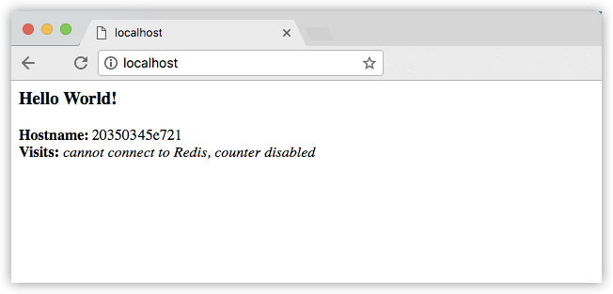

Either way, the container ID changes, demonstrating the load-balancing; with each request, one of the 5 tasks is chosen, in a round-robin fashion, to respond. The container IDs match your output from the previous command (docker container ls -q).

**Running Windows 10?**

Windows 10 PowerShell should already have curl available, but if not you can grab a Linux terminal emulator like Git BASH, or download wget for Windows which is very similar.

**Slow response times?**

Depending on your environment’s networking configuration, it may take up to 30 seconds for the containers to respond to HTTP requests. This is not indicative of Docker or swarm performance, but rather an unmet Redis dependency that we address later in the tutorial. For now, the visitor counter isn’t working for the same reason; we haven’t yet added a service to persist data.

## Scale the app

You can scale the app by changing the replicas value in docker-compose.yml, saving the change, and re-running the docker stack deploy command:

docker stack deploy -c docker-compose.yml getstartedlab

Docker performs an in-place update, no need to tear the stack down first or kill any containers.

Now, re-run docker container ls -q to see the deployed instances reconfigured. If you scaled up the replicas, more tasks, and hence, more containers, are started.

### Take down the app and the swarm

* Take the app down with docker stack rm:
* docker stack rm getstartedlab
* Take down the swarm.
* docker swarm leave --force

It’s as easy as that to stand up and scale your app with Docker. You’ve taken a huge step towards learning how to run containers in production. Up next, you learn how to run this app as a bonafide swarm on a cluster of Docker machines.

# Swarms

## Understanding Swarm clusters

A swarm is a group of machines that are running Docker and joined into a cluster. After that has happened, you continue to run the Docker commands you’re used to, but now they are executed on a cluster by a **swarm manager**. The machines in a swarm can be physical or virtual. After joining a swarm, they are referred to as **nodes**.

Swarm managers can use several strategies to run containers, such as “emptiest node” – which fills the least utilized machines with containers. Or “global”, which ensures that each machine gets exactly one instance of the specified container. You instruct the swarm manager to use these strategies in the Compose file, just like the one you have already been using.

Swarm managers are the only machines in a swarm that can execute your commands, or authorize other machines to join the swarm as **workers**. Workers are just there to provide capacity and do not have the authority to tell any other machine what it can and cannot do.

Up until now, you have been using Docker in a single-host mode on your local machine. But Docker also can be switched into **swarm mode**, and that’s what enables the use of swarms. Enabling swarm mode instantly makes the current machine a swarm manager. From then on, Docker runs the commands you execute on the swarm you’re managing, rather than just on the current machine.

## Set up your swarm

A swarm is made up of multiple nodes, which can be either physical or virtual machines. The basic concept is simple enough: run docker swarm init to enable swarm mode and make your current machine a swarm manager, then run docker swarm join on other machines to have them join the swarm as workers. Choose a tab below to see how this plays out in various contexts. We use VMs to quickly create a two-machine cluster and turn it into a swarm.

### Create a cluster

* Local VMs (Mac, Linux, Windows 7 and 8)
* Local VMs (Windows 10/Hyper-V)

#### VMS ON YOUR LOCAL MACHINE (MAC, LINUX, WINDOWS 7 AND 8)

You need a hypervisor that can create virtual machines (VMs), so install Oracle VirtualBox for your machine’s OS.

**Note**: If you are on a Windows system that has Hyper-V installed, such as Windows 10, there is no need to install VirtualBox and you should use Hyper-V instead. View the instructions for Hyper-V systems by clicking the Hyper-V tab above. If you are using Docker Toolbox, you should already have VirtualBox installed as part of it, so you are good to go.

Now, create a couple of VMs using docker-machine, using the VirtualBox driver:

docker-machine create --driver virtualbox myvm1

docker-machine create --driver virtualbox myvm2

#### LIST THE VMS AND GET THEIR IP ADDRESSES

You now have two VMs created, named myvm1 and myvm2.

Use this command to list the machines and get their IP addresses.

docker-machine ls

Here is example output from this command.

$ docker-machine ls

NAME ACTIVE DRIVER STATE URL SWARM DOCKER ERRORS

myvm1 - virtualbox Running tcp://192.168.99.100:2376 v17.06.2-ce

myvm2 - virtualbox Running tcp://192.168.99.101:2376 v17.06.2-ce

#### INITIALIZE THE SWARM AND ADD NODES

The first machine acts as the manager, which executes management commands and authenticates workers to join the swarm, and the second is a worker.

You can send commands to your VMs using docker-machine ssh. Instruct myvm1 to become a swarm manager with docker swarm init and look for output like this:

$ docker-machine ssh myvm1 "docker swarm init --advertise-addr <myvm1 ip>"

Swarm initialized: current node <node ID> is now a manager.

To add a worker to this swarm, run the following command:

docker swarm join \

--token <token> \

<myvm ip>:<port>

To add a manager to this swarm, run 'docker swarm join-token manager' and follow the instructions.

**Ports 2377 and 2376**

Always run docker swarm init and docker swarm join with port 2377 (the swarm management port), or no port at all and let it take the default.

The machine IP addresses returned by docker-machine ls include port 2376, which is the Docker daemon port. Do not use this port or you may experience errors.

**Having trouble using SSH? Try the –native-ssh flag**

Docker Machine has the option to let you use your own system’s SSH, if for some reason you’re having trouble sending commands to your Swarm manager. Just specify the --native-ssh flag when invoking the ssh command:

docker-machine --native-ssh ssh myvm1 ...

As you can see, the response to docker swarm init contains a pre-configured docker swarm join command for you to run on any nodes you want to add. Copy this command, and send it to myvm2 via docker-machine ssh to have myvm2 join your new swarm as a worker:

$ docker-machine ssh myvm2 "docker swarm join \

--token <token> \

<ip>:2377"

This node joined a swarm as a worker.

Congratulations, you have created your first swarm!

Run docker node ls on the manager to view the nodes in this swarm:

$ docker-machine ssh myvm1 "docker node ls"

ID HOSTNAME STATUS AVAILABILITY MANAGER STATUS

brtu9urxwfd5j0zrmkubhpkbd myvm2 Ready Active

rihwohkh3ph38fhillhhb84sk * myvm1 Ready Active Leader

**Leaving a swarm**

If you want to start over, you can run docker swarm leave from each node.

## Deploy your app on the swarm cluster

The hard part is over. Now you just repeat the process you used in part 3 to deploy on your new swarm. Just remember that only swarm managers like myvm1 execute Docker commands; workers are just for capacity.

### Configure a docker-machine shell to the swarm manager

So far, you’ve been wrapping Docker commands in docker-machine ssh to talk to the VMs. Another option is to run docker-machine env <machine> to get and run a command that configures your current shell to talk to the Docker daemon on the VM. This method works better for the next step because it allows you to use your local docker-compose.yml file to deploy the app “remotely” without having to copy it anywhere.

Type docker-machine env myvm1, then copy-paste and run the command provided as the last line of the output to configure your shell to talk to myvm1, the swarm manager.

The commands to configure your shell differ depending on whether you are Mac, Linux, or Windows, so examples of each are shown on the tabs below.

* Mac, Linux
* Windows

#### DOCKER MACHINE SHELL ENVIRONMENT ON MAC OR LINUX

Run docker-machine env myvm1 to get the command to configure your shell to talk to myvm1.

$ docker-machine env myvm1

export DOCKER_TLS_VERIFY="1"

export DOCKER_HOST="tcp://192.168.99.100:2376"

export DOCKER_CERT_PATH="/Users/sam/.docker/machine/machines/myvm1"

export DOCKER_MACHINE_NAME="myvm1"

# Run this command to configure your shell:

# eval $(docker-machine env myvm1)

Run the given command to configure your shell to talk to myvm1.

eval $(docker-machine env myvm1)

Run docker-machine ls to verify that myvm1 is now the active machine, as indicated by the asterisk next to it.

$ docker-machine ls

NAME ACTIVE DRIVER STATE URL SWARM DOCKER ERRORS

myvm1 * virtualbox Running tcp://192.168.99.100:2376 v17.06.2-ce

myvm2 - virtualbox Running tcp://192.168.99.101:2376 v17.06.2-ce

### Deploy the app on the swarm manager

Now that you have myvm1, you can use its powers as a swarm manager to deploy your app by using the same docker stack deploy command you used in part 3 to myvm1, and your local copy of docker-compose.yml.. This command may take a few seconds to complete and the deployment takes some time to be available. Use the docker service ps <service_name>command on a swarm manager to verify that all services have been redeployed.

You are connected to myvm1 by means of the docker-machine shell configuration, and you still have access to the files on your local host. Make sure you are in the same directory as before, which includes the docker-compose.yml file you created in part 3.

Just like before, run the following command to deploy the app on myvm1.

docker stack deploy -c docker-compose.yml getstartedlab

And that’s it, the app is deployed on a swarm cluster!

**Note: If your image is stored on a private registry instead of Docker Hub, you need to be logged in using docker login <your-registry> and then you need to add the --with-registry-auth flag to the above command. For example:**

docker login registry.example.com

docker stack deploy --with-registry-auth -c docker-compose.yml getstartedlab

This passes the login token from your local client to the swarm nodes where the service is deployed, using the encrypted WAL logs. With this information, the nodes are able to log into the registry and pull the image.

Now you can use the same docker commands you used in part 3. Only this time notice that the services (and associated containers) have been distributed between both myvm1 and myvm2.

$ docker stack ps getstartedlab

ID NAME IMAGE NODE DESIRED STATE

jq2g3qp8nzwx getstartedlab_web.1 john/get-started:part2 myvm1 Running

88wgshobzoxl getstartedlab_web.2 john/get-started:part2 myvm2 Running

vbb1qbkb0o2z getstartedlab_web.3 john/get-started:part2 myvm2 Running

ghii74p9budx getstartedlab_web.4 john/get-started:part2 myvm1 Running

0prmarhavs87 getstartedlab_web.5 john/get-started:part2 myvm2 Running

**Connecting to VMs with docker-machine env and docker-machine ssh**

* To set your shell to talk to a different machine like myvm2, simply re-run docker-machine env in the same or a different shell, then run the given command to point to myvm2. This is always specific to the current shell. If you change to an unconfigured shell or open a new one, you need to re-run the commands. Use docker-machine ls to list machines, see what state they are in, get IP addresses, and find out which one, if any, you are connected to. To learn more, see the Docker Machine getting started topics.
* Alternatively, you can wrap Docker commands in the form of docker-machine ssh <machine> "<command>", which logs directly into the VM but doesn’t give you immediate access to files on your local host.
* On Mac and Linux, you can use docker-machine scp <file> <machine>:~ to copy files across machines, but Windows users need a Linux terminal emulator like Git Bash for this to work.

This tutorial demos both docker-machine ssh and docker-machine env, since these are available on all platforms via the docker-machine CLI.

### Accessing your cluster

You can access your app from the IP address of **either** myvm1 or myvm2.

The network you created is shared between them and load-balancing. Run docker-machine ls to get your VMs’ IP addresses and visit either of them on a browser, hitting refresh (or just curl them).

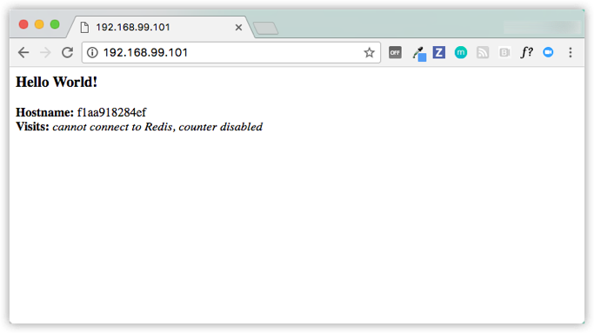

There are five possible container IDs all cycling by randomly, demonstrating the load-balancing.

The reason both IP addresses work is that nodes in a swarm participate in an ingress **routing mesh**. This ensures that a service deployed at a certain port within your swarm always has that port reserved to itself, no matter what node is actually running the container. Here’s a diagram of how a routing mesh for a service called my-web published at port 8080 on a three-node swarm would look:

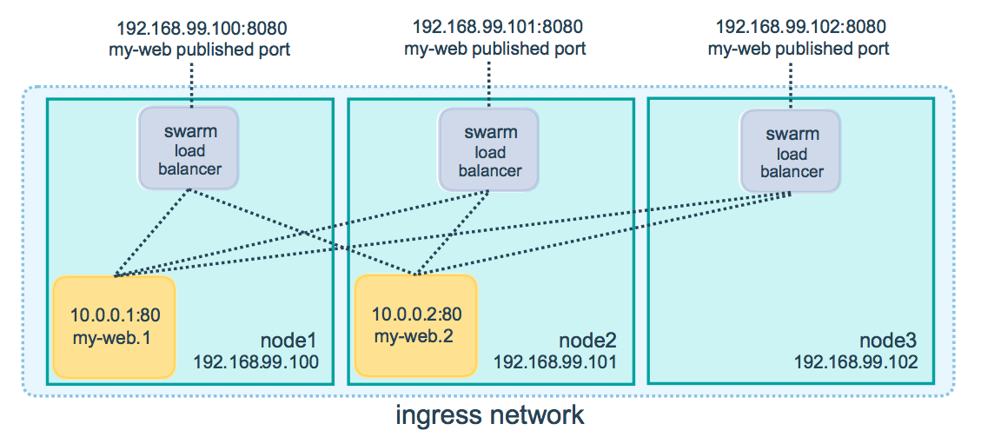

**Having connectivity trouble?**

Keep in mind that to use the ingress network in the swarm, you need to have the following ports open between the swarm nodes before you enable swarm mode:

* Port 7946 TCP/UDP for container network discovery.
* Port 4789 UDP for the container ingress network.

## Iterating and scaling your app

From here you can do everything you learned about in parts 2 and 3.

Scale the app by changing the docker-compose.yml file.

Change the app behavior by editing code, then rebuild, and push the new image. (To do this, follow the same steps you took earlier to build the app and publish the image).

In either case, simply run docker stack deploy again to deploy these changes.

You can join any machine, physical or virtual, to this swarm, using the same docker swarm join command you used on myvm2, and capacity is added to your cluster. Just run docker stack deploy afterwards, and your app can take advantage of the new resources.

## Cleanup and reboot

### Stacks and swarms

You can tear down the stack with docker stack rm. For example:

docker stack rm getstartedlab

**Keep the swarm or remove it?**

At some point later, you can remove this swarm if you want to with docker-machine ssh myvm2 "docker swarm leave" on the worker and docker-machine ssh myvm1 "docker swarm leave --force" on the manager, but you need this swarm for part 5, so keep it around for now.

### Unsetting docker-machine shell variable settings

You can unset the docker-machine environment variables in your current shell with the following command:

eval $(docker-machine env -u)

This disconnects the shell from docker-machine created virtual machines, and allows you to continue working in the same shell, now using native docker commands (for example, on Docker for Mac or Docker for Windows). To learn more, see the Machine topic on unsetting environment variables.

### Restarting Docker machines

If you shut down your local host, Docker machines stops running. You can check the status of machines by running docker-machine ls.

$ docker-machine ls

NAME ACTIVE DRIVER STATE URL SWARM DOCKER ERRORS

myvm1 - virtualbox Stopped Unknown

myvm2 - virtualbox Stopped Unknown

To restart a machine that’s stopped, run:

docker-machine start <machine-name>

For example:

$ docker-machine start myvm1

Starting "myvm1"...

(myvm1) Check network to re-create if needed...

(myvm1) Waiting for an IP...

Machine "myvm1" was started.

Waiting for SSH to be available...

Detecting the provisioner...

Started machines may have new IP addresses. You may need to re-run the `docker-machine env` command.

$ docker-machine start myvm2

Starting "myvm2"...

(myvm2) Check network to re-create if needed...

(myvm2) Waiting for an IP...

Machine "myvm2" was started.

Waiting for SSH to be available...

Detecting the provisioner...

Started machines may have new IP addresses. You may need to re-run the `docker-machine env` command.

# Stacks

Introduction

In part 4, you learned how to set up a swarm, which is a cluster of machines running Docker, and deployed an application to it, with containers running in concert on multiple machines.

Here in part 5, you reach the top of the hierarchy of distributed applications: the **stack**. A stack is a group of interrelated services that share dependencies, and can be orchestrated and scaled together. A single stack is capable of defining and coordinating the functionality of an entire application (though very complex applications may want to use multiple stacks).

Some good news is, you have technically been working with stacks since part 3, when you created a Compose file and used docker stack deploy. But that was a single service stack running on a single host, which is not usually what takes place in production. Here, you can take what you’ve learned, make multiple services relate to each other, and run them on multiple machines.

You’re doing great, this is the home stretch!

Add a new service and redeploy

It’s easy to add services to our docker-compose.yml file. First, let’s add a free visualizer service that lets us look at how our swarm is scheduling containers.

1. Open up docker-compose.yml in an editor and replace its contents with the following. Be sure to replace username/repo:tag with your image details.
2. version: "3"
3. services:
4. web:
5. # replace username/repo:tag with your name and image details
6. image: username/repo:tag
7. deploy:
8. replicas: 5
9. restart_policy:
10. condition: on-failure
11. resources:
12. limits:
13. cpus: "0.1"
14. memory: 50M
15. ports:
16. - "80:80"
17. networks:
18. - webnet
19. visualizer:
20. image: dockersamples/visualizer:stable
21. ports:
22. - "8080:8080"
23. volumes:
24. - "/var/run/docker.sock:/var/run/docker.sock"
25. deploy:
26. placement:
27. constraints: [node.role == manager]
28. networks:
29. - webnet
30. networks:
31. webnet:

The only thing new here is the peer service to web, named visualizer. Notice two new things here: a volumes key, giving the visualizer access to the host’s socket file for Docker, and a placement key, ensuring that this service only ever runs on a swarm manager – never a worker. That’s because this container, built from an open source project created by Docker, displays Docker services running on a swarm in a diagram.

We talk more about placement constraints and volumes in a moment.

1. Make sure your shell is configured to talk to myvm1 (full examples are here).
   * Run docker-machine ls to list machines and make sure you are connected to myvm1, as indicated by an asterisk next it.
   * If needed, re-run docker-machine env myvm1, then run the given command to configure the shell.

On **Mac or Linux** the command is:

eval $(docker-machine env myvm1)

On **Windows** the command is:

& "C:\Program Files\Docker\Docker\Resources\bin\docker-machine.exe" env myvm1 | Invoke-Expression

1. Re-run the docker stack deploy command on the manager, and whatever services need updating are updated:
2. $ docker stack deploy -c docker-compose.yml getstartedlab
3. Updating service getstartedlab_web (id: angi1bf5e4to03qu9f93trnxm)
4. Creating service getstartedlab_visualizer (id: l9mnwkeq2jiononb5ihz9u7a4)
5. Take a look at the visualizer.

You saw in the Compose file that visualizer runs on port 8080. Get the IP address of one of your nodes by running docker-machine ls. Go to either IP address at port 8080 and you can see the visualizer running:

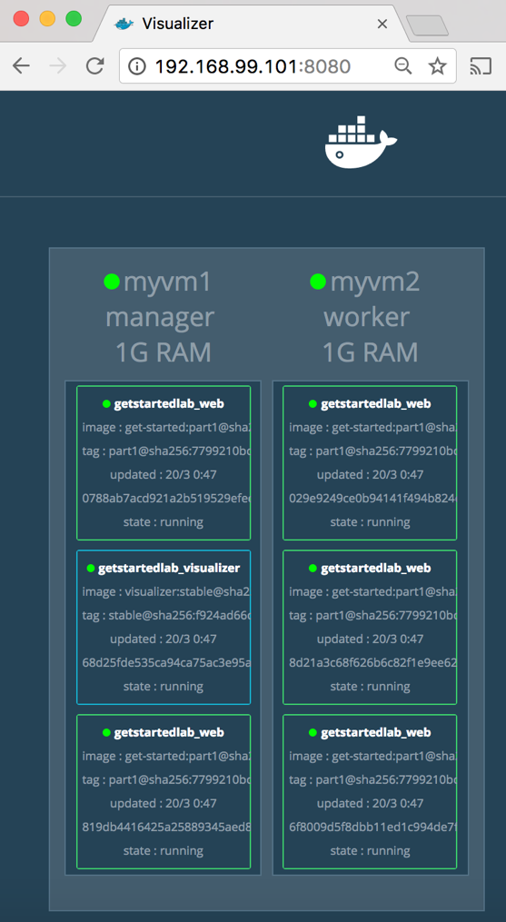

The single copy of visualizer is running on the manager as you expect, and the 5 instances of web are spread out across the swarm. You can corroborate this visualization by running docker stack ps <stack>:

docker stack ps getstartedlab

The visualizer is a standalone service that can run in any app that includes it in the stack. It doesn’t depend on anything else. Now let’s create a service that *does* have a dependency: the Redis service that provides a visitor counter.

Persist the data

Let’s go through the same workflow once more to add a Redis database for storing app data.

1. Save this new docker-compose.yml file, which finally adds a Redis service. Be sure to replace username/repo:tag with your image details.
2. version: "3"
3. services:
4. web:
5. # replace username/repo:tag with your name and image details
6. image: username/repo:tag
7. deploy:
8. replicas: 5
9. restart_policy:
10. condition: on-failure
11. resources:
12. limits:
13. cpus: "0.1"
14. memory: 50M
15. ports:
16. - "80:80"
17. networks:
18. - webnet
19. visualizer:
20. image: dockersamples/visualizer:stable
21. ports:
22. - "8080:8080"
23. volumes:
24. - "/var/run/docker.sock:/var/run/docker.sock"
25. deploy:
26. placement:
27. constraints: [node.role == manager]
28. networks:
29. - webnet
30. redis:
31. image: redis
32. ports:
33. - "6379:6379"
34. volumes:
35. - "/home/docker/data:/data"
36. deploy:
37. placement:
38. constraints: [node.role == manager]
39. command: redis-server --appendonly yes
40. networks:
41. - webnet
42. networks:
43. webnet:

Redis has an official image in the Docker library and has been granted the short image name of just redis, so no username/repo notation here. The Redis port, 6379, has been pre-configured by Redis to be exposed from the container to the host, and here in our Compose file we expose it from the host to the world, so you can actually enter the IP for any of your nodes into Redis Desktop Manager and manage this Redis instance, if you so choose.

Most importantly, there are a couple of things in the redis specification that make data persist between deployments of this stack:

* + redis always runs on the manager, so it’s always using the same filesystem.
  + redis accesses an arbitrary directory in the host’s file system as /data inside the container, which is where Redis stores data.

Together, this is creating a “source of truth” in your host’s physical filesystem for the Redis data. Without this, Redis would store its data in /data inside the container’s filesystem, which would get wiped out if that container were ever redeployed.

This source of truth has two components:

* + The placement constraint you put on the Redis service, ensuring that it always uses the same host.
  + The volume you created that lets the container access ./data (on the host) as /data (inside the Redis container). While containers come and go, the files stored on ./data on the specified host persists, enabling continuity.

You are ready to deploy your new Redis-using stack.

1. Create a ./data directory on the manager:
2. docker-machine ssh myvm1 "mkdir ./data"
3. Make sure your shell is configured to talk to myvm1 (full examples are here).
   * Run docker-machine ls to list machines and make sure you are connected to myvm1, as indicated by an asterisk next it.
   * If needed, re-run docker-machine env myvm1, then run the given command to configure the shell.

On **Mac or Linux** the command is:

eval $(docker-machine env myvm1)

On **Windows** the command is:

& "C:\Program Files\Docker\Docker\Resources\bin\docker-machine.exe" env myvm1 | Invoke-Expression

1. Run docker stack deploy one more time.
2. $ docker stack deploy -c docker-compose.yml getstartedlab
3. Run docker service ls to verify that the three services are running as expected.
4. $ docker service ls
5. ID NAME MODE REPLICAS IMAGE PORTS
6. x7uij6xb4foj getstartedlab_redis replicated 1/1 redis:latest *:6379->6379/tcp
7. n5rvhm52ykq7 getstartedlab_visualizer replicated 1/1 dockersamples/visualizer:stable *:8080->8080/tcp
8. mifd433bti1d getstartedlab_web replicated 5/5 orangesnap/getstarted:latest *:80->80/tcp
9. Check the web page at one of your nodes, such as http://192.168.99.101, and take a look at the results of the visitor counter, which is now live and storing information on Redis.

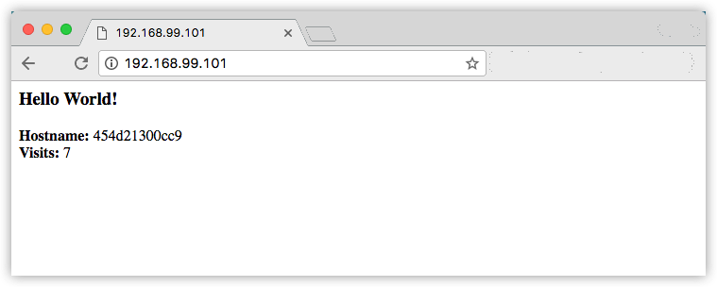

Also, check the visualizer at port 8080 on either node’s IP address, and notice see the redis service running along with the web and visualizer services.

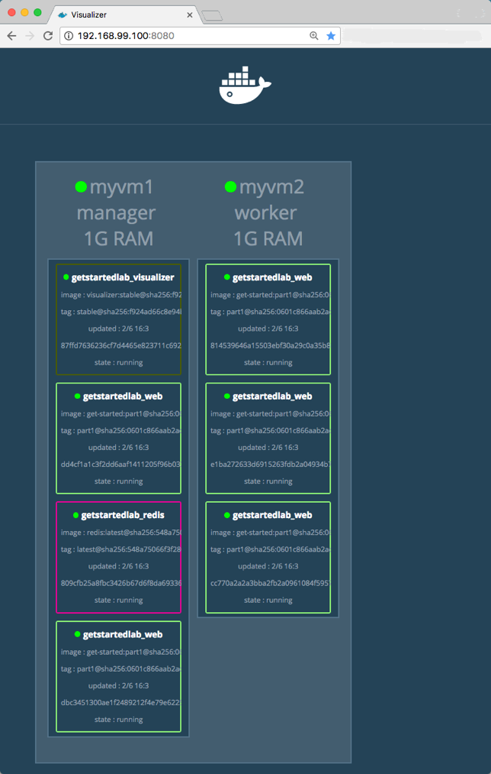

# Deploy your app

## Introduction

You’ve been editing the same Compose file for this entire tutorial. Well, we have good news. That Compose file works just as well in production as it does on your machine. Here, We go through some options for running your Dockerized application.

## Choose an option

* Docker CE (Cloud provider)
* Enterprise (Cloud provider)
* Enterprise (On-premise)

If you’re okay with using Docker Community Edition in production, you can use Docker Cloud to help manage your app on popular service providers such as Amazon Web Services, DigitalOcean, and Microsoft Azure.

To set up and deploy:

* Connect Docker Cloud with your preferred provider, granting Docker Cloud permission to automatically provision and “Dockerize” VMs for you.
* Use Docker Cloud to create your computing resources and create your swarm.
* Deploy your app.

**Note**: We do not link into the Docker Cloud documentation here; be sure to come back to this page after completing each step.

### Connect Docker Cloud

You can run Docker Cloud in standard mode or in Swarm mode.

If you are running Docker Cloud in standard mode, follow instructions below to link your service provider to Docker Cloud.

* Amazon Web Services setup guide
* DigitalOcean setup guide
* Microsoft Azure setup guide
* Packet setup guide
* SoftLayer setup guide
* Use the Docker Cloud Agent to bring your own host

If you are running in Swarm mode (recommended for Amazon Web Services or Microsoft Azure), then skip to the next section on how to create your swarm.

### Create your swarm

Ready to create a swarm?

* If you’re on Amazon Web Services (AWS) you can automatically create a swarm on AWS.
* If you are on Microsoft Azure, you can automatically create a swarm on Azure.
* Otherwise, create your nodes in the Docker Cloud UI, and run the docker swarm init and docker swarm join commands you learned in part 4 over SSH via Docker Cloud. Finally, enable Swarm Mode by clicking the toggle at the top of the screen, and register the  swarm you just created.

**Note**: If you are Using the Docker Cloud Agent to Bring your Own Host, this provider does not support swarm mode. You can register your own existing swarms with Docker Cloud.

### Deploy your app on a cloud provider

1. Connect to your swarm via Docker Cloud. There are a couple of different ways to connect:
   * From the Docker Cloud web interface in Swarm mode, select Swarms at the top of the page, click the swarm you want to connect to, and copy-paste the given command into a command line terminal.

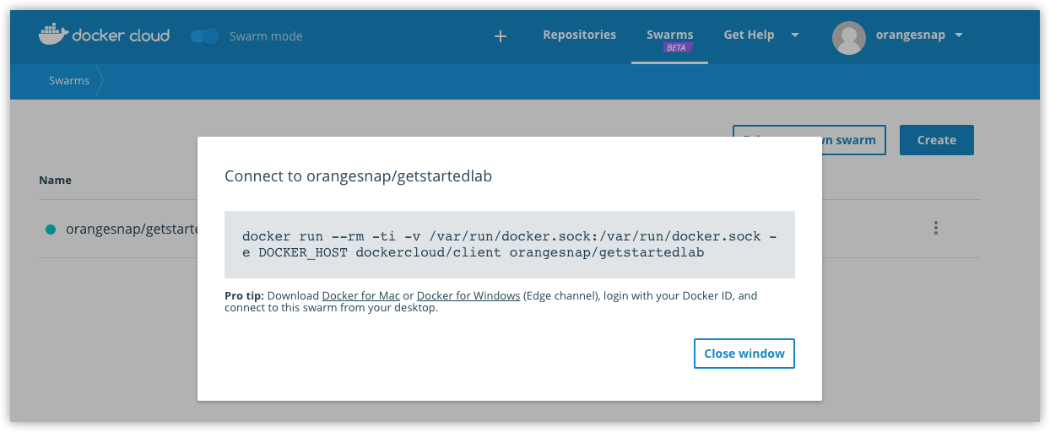

Or …

* + On Docker for Mac or Docker for Windows, you can connect to your swarms directly through the desktop app menus.

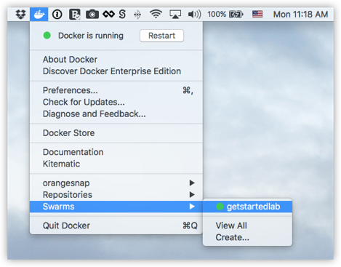

Either way, this opens a terminal whose context is your local machine, but whose Docker commands are routed up to the swarm running on your cloud service provider. You directly access both your local file system and your remote swarm, enabling pure docker commands.

1. Run docker stack deploy -c docker-compose.yml getstartedlab to deploy the app on the cloud hosted swarm.
2. docker stack deploy -c docker-compose.yml getstartedlab
3. Creating network getstartedlab_webnet
4. Creating service getstartedlab_web
5. Creating service getstartedlab_visualizer
6. Creating service getstartedlab_redis

Your app is now running on your cloud provider.

#### RUN SOME SWARM COMMANDS TO VERIFY THE DEPLOYMENT

You can use the swarm command line, as you’ve done already, to browse and manage the swarm. Here are some examples that should look familiar by now:

* Use docker node ls to list the nodes.
* [getstartedlab] ~ $ docker node ls
* ID HOSTNAME STATUS AVAILABILITY MANAGER STATUS
* 9442yi1zie2l34lj01frj3lsn ip-172-31-5-208.us-west-1.compute.internal Ready Active
* jr02vg153pfx6jr0j66624e8a ip-172-31-6-237.us-west-1.compute.internal Ready Active
* thpgwmoz3qefdvfzp7d9wzfvi ip-172-31-18-121.us-west-1.compute.internal Ready Active
* n2bsny0r2b8fey6013kwnom3m * ip-172-31-20-217.us-west-1.compute.internal Ready Active Leader
* Use docker service ls to list services.
* [getstartedlab] ~/sandbox/getstart $ docker service ls
* ID NAME MODE REPLICAS IMAGE PORTS
* x3jyx6uukog9 dockercloud-server-proxy global 1/1 dockercloud/server-proxy *:2376->2376/tcp
* ioipby1vcxzm getstartedlab_redis replicated 0/1 redis:latest *:6379->6379/tcp
* u5cxv7ppv5o0 getstartedlab_visualizer replicated 0/1 dockersamples/visualizer:stable *:8080->8080/tcp
* vy7n2piyqrtr getstartedlab_web replicated 5/5 sam/getstarted:part6 *:80->80/tcp
* Use docker service ps <service> to view tasks for a service.
* [getstartedlab] ~/sandbox/getstart $ docker service ps vy7n2piyqrtr
* ID NAME IMAGE NODE DESIRED STATE CURRENT STATE ERROR PORTS
* qrcd4a9lvjel getstartedlab_web.1 sam/getstarted:part6 ip-172-31-5-208.us-west-1.compute.internal Running Running 20 seconds ago
* sknya8t4m51u getstartedlab_web.2 sam/getstarted:part6 ip-172-31-6-237.us-west-1.compute.internal Running Running 17 seconds ago
* ia730lfnrslg getstartedlab_web.3 sam/getstarted:part6 ip-172-31-20-217.us-west-1.compute.internal Running Running 21 seconds ago
* 1edaa97h9u4k getstartedlab_web.4 sam/getstarted:part6 ip-172-31-18-121.us-west-1.compute.internal Running Running 21 seconds ago
* uh64ez6ahuew getstartedlab_web.5 sam/getstarted:part6 ip-172-31-18-121.us-west-1.compute.internal Running Running 22 seconds ago

#### OPEN PORTS TO SERVICES ON CLOUD PROVIDER MACHINES

At this point, your app is deployed as a swarm on your cloud provider servers, as evidenced by the docker commands you just ran. But, you still need to open ports on your cloud servers in order to:

* allow communication between the redis service and web service on the worker nodes
* allow inbound traffic to the web service on the worker nodes so that Hello World and Visualizer are accessible from a web browser.
* allow inbound SSH traffic on the server that is running the manager (this may be already set on your cloud provider)

These are the ports you need to expose for each service:

| **Service** | **Type** | **Protocol** | **Port** |
| --- | --- | --- | --- |
| web | HTTP | TCP | 80 |
| visualizer | HTTP | TCP | 8080 |
| redis | TCP | TCP | 6379 |

Methods for doing this vary depending on your cloud provider.

We use Amazon Web Services (AWS) as an example.

**What about the redis service to persist data?**

To get the redis service working, you need to ssh into the cloud server where the manager is running, and make a data/ directory in /home/docker/ before you run docker stack deploy. Another option is to change the data path in the docker-stack.yml to a pre-existing path on the manager server. This example does not include this step, so the redis service is not up in the example output.

#### EXAMPLE: AWS

1. Log in to the AWS Console, go to the EC2 Dashboard, and click into your **Running Instances** to view the nodes.
2. On the left menu, go to Network & Security > **Security Groups**.

See the security groups related to your swarm for getstartedlab-Manager-<xxx>, getstartedlab-Nodes-<xxx>, and getstartedlab-SwarmWide-<xxx>.

1. Select the “Node” security group for the swarm. The group name is something like this: getstartedlab-NodeVpcSG-9HV9SMHDZT8C.
2. Add Inbound rules for the web, visualizer, and redis services, setting the Type, Protocol and Port for each as shown in the table above, and click **Save** to apply the rules.



**Tip**: When you save the new rules, HTTP and TCP ports are auto-created for both IPv4 and IPv6 style addresses.

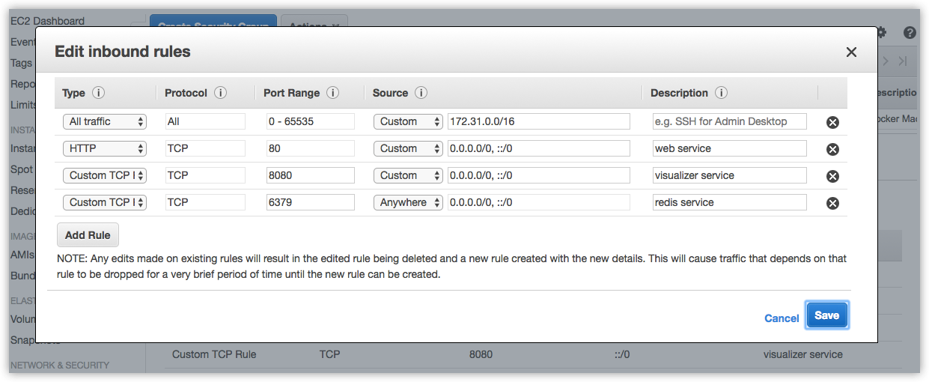

1. Go to the list of **Running Instances**, get the public DNS name for one of the workers, and paste it into the address bar of your web browser.

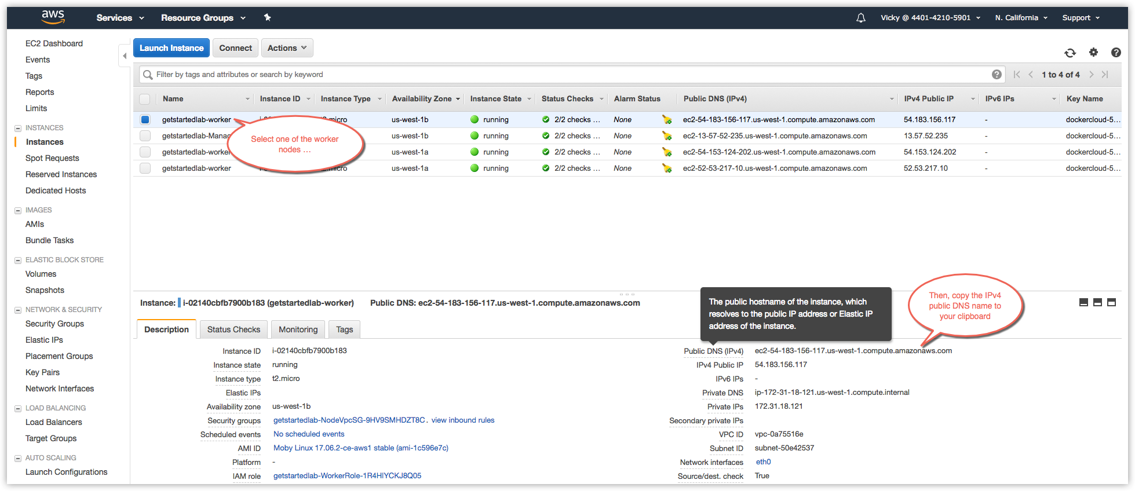

Just as in the previous parts of the tutorial, the Hello World app displays on port 80, and the Visualizer displays on port 8080.

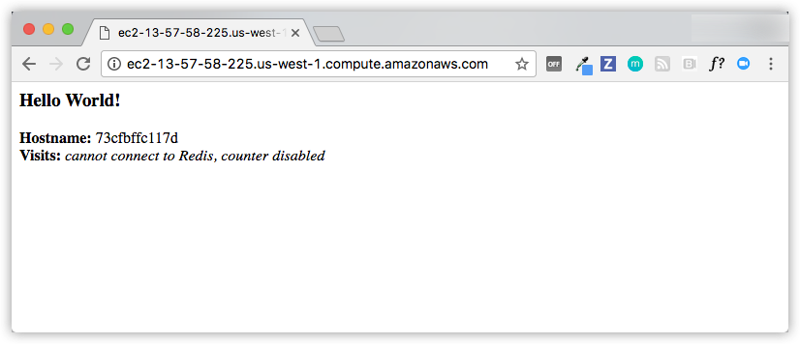

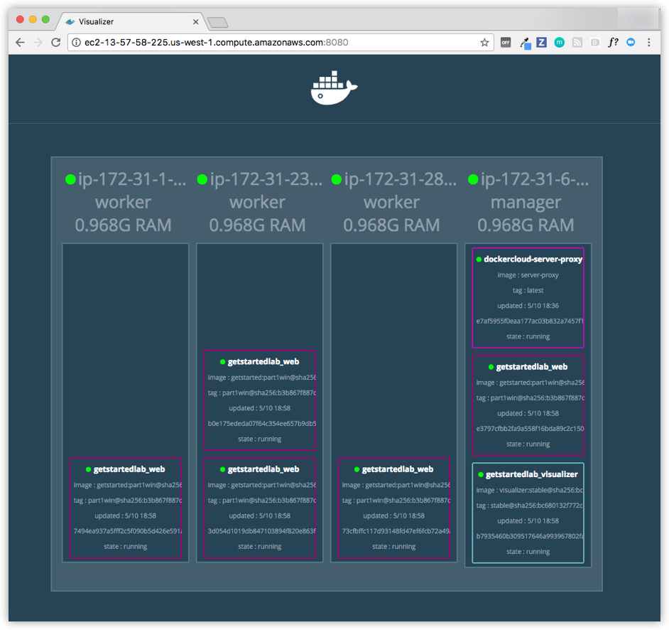

### Iteration and cleanup

From here you can do everything you learned about in previous parts of the tutorial.

* Scale the app by changing the docker-compose.yml file and redeploy on-the-fly with the docker stack deploy command.
* Change the app behavior by editing code, then rebuild, and push the new image. (To do this, follow the same steps you took earlier to build the app and publish the image).
* You can tear down the stack with docker stack rm. For example:
* docker stack rm getstartedlab

Unlike the scenario where you were running the swarm on local Docker machine VMs, your swarm and any apps deployed on it continue to run on cloud servers regardless of whether you shut down your local host.